Problem Statement 1:

Code snapshot:

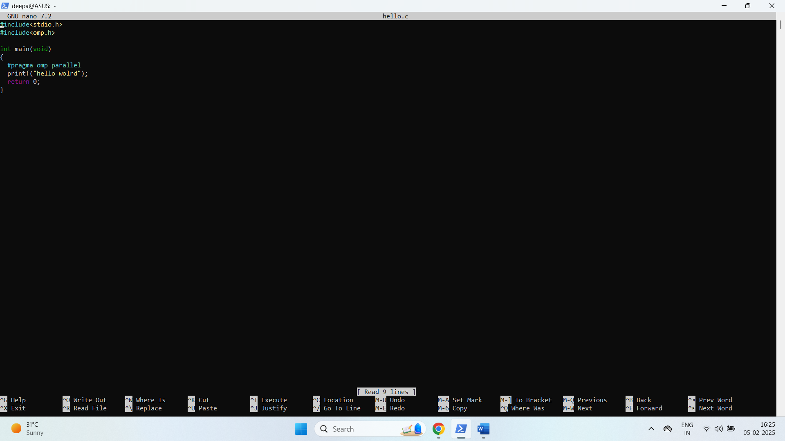

Output snapshot:

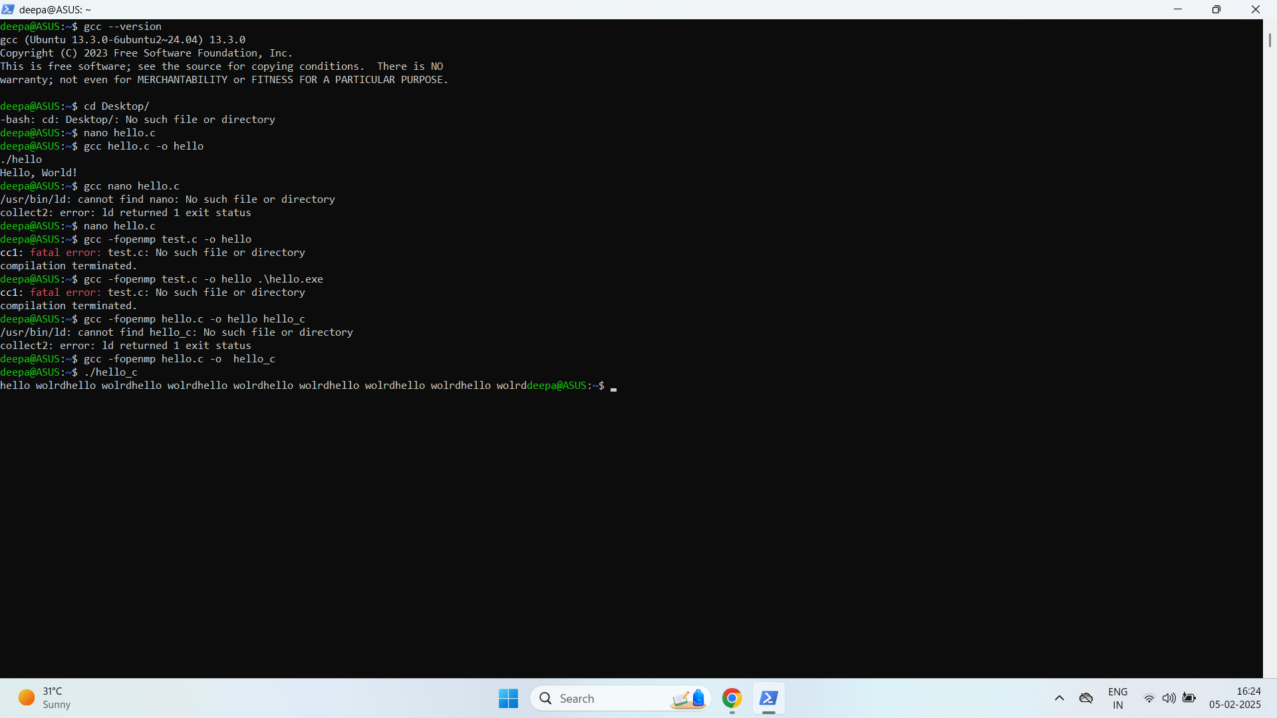

Problem Statement 2

Code Snapshot

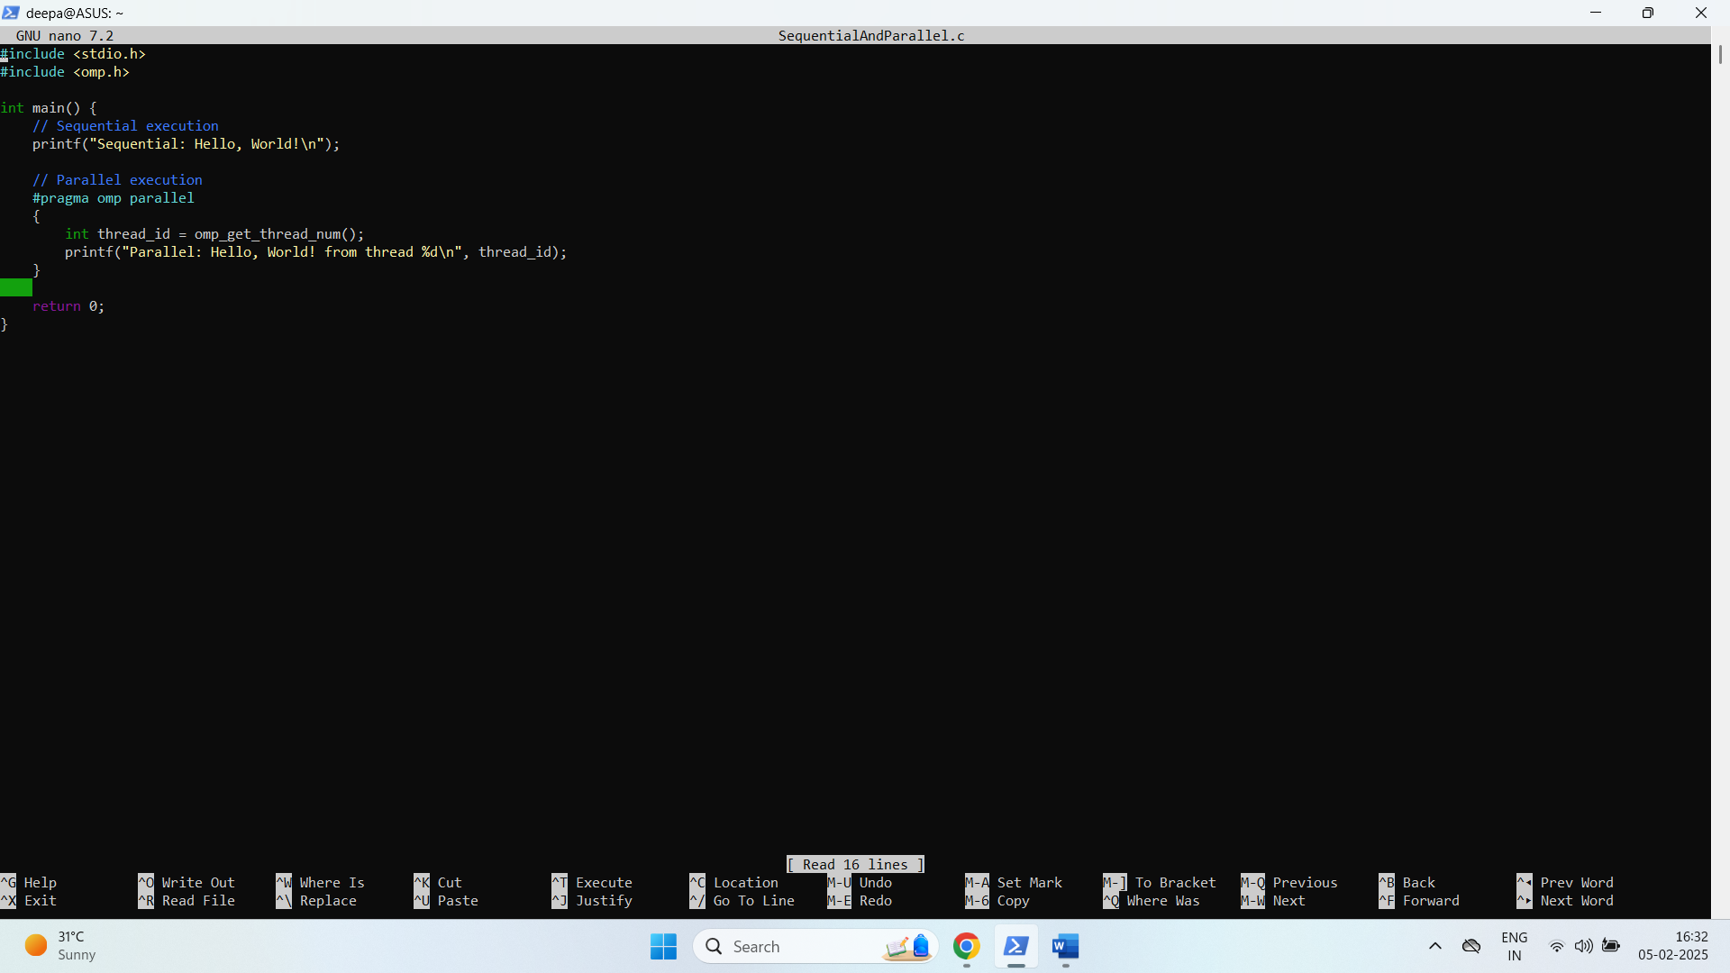

Output Snapshot

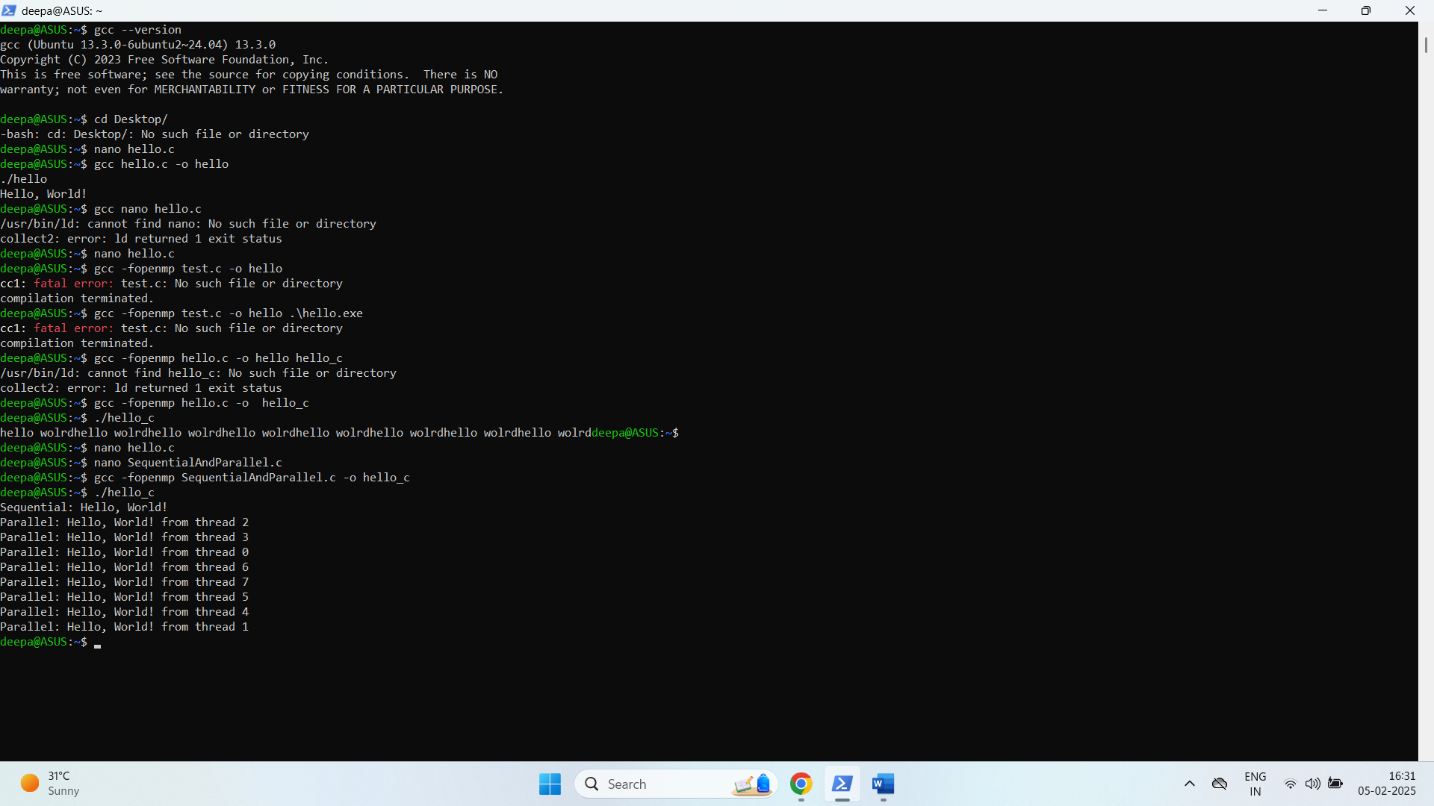

Problem Statement 3:

FLOPS=Clock Speed×Cores×FLOP per Cycle

* Clock Speed = 4.4 GHz = 4.4 × 10⁹ cycles/sec
* Cores = 4 cores
* FLOPs per Cycle (AVX2) = 8 FLOPs

Theoretical FLOPS=4.4×10^9×4×8

FLOPS=141.44×10^9 FLOPS=141.44 GFLOPS

GITHUB Link-